**Aircraft Physics**

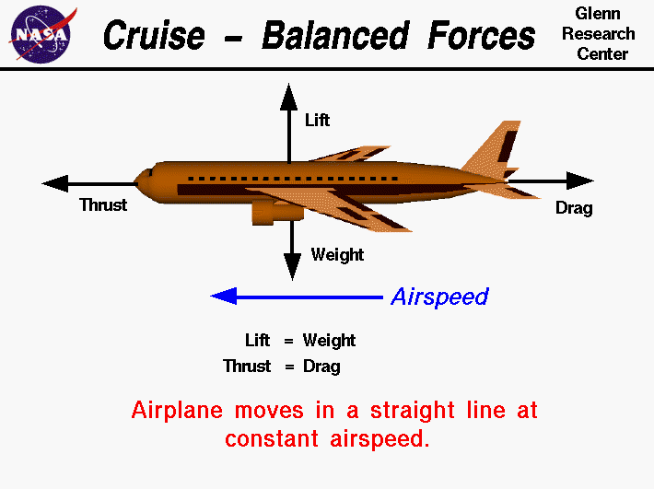

<http://ffden-2.phys.uaf.edu/211_fall2013.web.dir/Cody_Gaines/Aerodynamic%20Forces.gif>

These are some of the forces that will need to be taken into consideration.

The reason the aircraft creates lift is due to the air splitting at the front of the wings. The air pressure increases underneath due to the curvature of the wings. On top of the wings, the air accelerates downwards, creating lift.

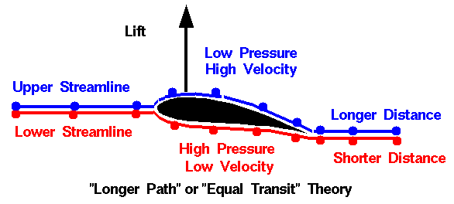

<https://upload.wikimedia.org/wikipedia/commons/2/2d/Equal_transit-time_NASA_wrong1.gif>